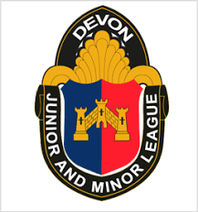

DRDL Sports Club
Devon Junior & Minor league
Emergency Player Registration Form 5A
Season 2026 / 2027

Where clubs are unable to register players by the league deadline for accepting players for the next round of fixtures because they cannot access their Club Portal system then you can use this form to register players offline, this form must be sent to League Registration Officers.
*The Club agrees to register these players on the Club Portal system as soon as they are able to access the system.

Club Name:

Name of the Team (eg. Town United Reds)

Age group of team

◯ Under 7 ◯ Under 8 ◯ Under 9 ◯ Under 10 ◯ Under 11 ◯ Under 12 ◯ Under 13 ◯ Under 14 ◯ Under 15 ◯ Under 16 ◯ Under 18
◯ Mixed League ◯ Girls

Fan Number (If known) | Name of Player | Date of Birth

